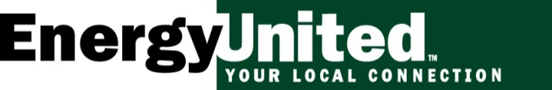

For Immediate Release: Media contact:
February 20, 2019 Maureen Moore, Communications Manager
704-924-2159
Maureen.moore@energyunited.com

ENERGYUNITED JOINS ‘PLUG-IN NC’ IN EFFORT TO SUPPORT ELECTRIC VEHICLE ADOPTION
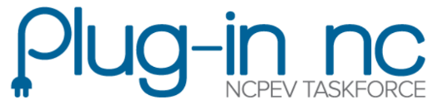
STATESVILLE, N.C. – EnergyUnited is pleased to announce the co-op has become a member of Plug-In NC, a statewide advocacy group that supports Plug-In Electric Vehicle (PEV) adoption.
Plug-in NC was started by the North Carolina Plug-in Electric Vehicle Taskforce to track electric vehicle efforts occurring across the state, and to raise awareness of the environmental benefits of driving an electric vehicle. Reports from 2018 show that there are currently over 10,600 electric vehicles registered in the state and nearly 600 public charging stations installed across the state, with over 1,250 ports that electric vehicle drivers can plug into.
EnergyUnited is supporting driving electric by continuing to add additional charging stations throughout its service area. The electric cooperative already offers public access to charging stations at its offices in Lexington and Statesville, and in 2019 will be installing charging stations at its Madison and Cornelius locations.
The co-op’s efforts to boost the adoption of electric vehicles is more expansive than its charging network initiative. EnergyUnited is also showcasing the advancement in technology that is complementing the growth of the electric vehicle industry with the recent addition of Tesla’s Model 3 to the company fleet.
“We are proud to be part of this movement to encourage electric vehicle adoption throughout our service area with the help of Plug-In NC,” said Maureen Moore, Communications Manager for EnergyUnited. “Powerful partnerships like this will ultimately spark the development of new, innovative ideas that can help us solve our communities’ toughest challenges.”
Plug-In NC works with its members directly to support the development of new ideas to boost PEV adoption, and they are especially excited about EnergyUnited’s efforts.
“EnergyUnited is working hard to support electric vehicle adoption in North Carolina,” said Kristi Brodd, Outreach Coordinator for the NC PEV Taskforce. “We are thankful for their efforts and excited to see the continued growth in electric vehicle purchases and charging station installations across our state.”

About Plug-in NC:
Plug-in NC (www.pluginnc.com) is a state-wide recognition program that was launched in 2014 by the North Carolina Plug-in Electric Vehicle Taskforce and Advanced Energy. The program recognizes North Carolina businesses, schools, communities and organizations that have installed charging stations or purchased electric fleet vehicles.

About EnergyUnited
EnergyUnited Electric Membership Corporation (EMC) is the largest electric cooperative in North Carolina serving nearly 130,000 metering points. Headquartered in Statesville, EnergyUnited provides electric service in portions of nineteen counties in west central North Carolina which include Alexander, Cabarrus, Caldwell, Catawba, Davidson, Davie, Forsyth, Gaston, Guilford, Iredell, Lincoln, Mecklenburg, Montgomery, Randolph, Rockingham, Rowan, Stokes, Wilkes and Yadkin. EnergyUnited Propane provides products and services to more than 25,000 residential, commercial and industrial customers in 74 counties across North and South Carolina. Visit EnergyUnited online at www.energyunited.com to learn more about our electric and propane businesses.

